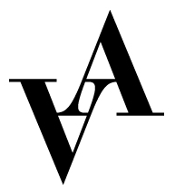

Application to marketing assistant 2025
Vadstena-Akademien

Production: Alessandro in Susa and Den Starkare.
Place: Vadstena Castle and Vadstena Old Theatre, Vadstena

Please fill out this form and send it together with CV, cover letter and 2 relevant references to apply@vadstena-akademien.org no later than February 14, 2025.

Name:

Address:

Postal number:

City:

Country:

Email:

Phone:

Birth year:

Education:

School:

Length of education:

Relevant internships within the area:

Previous experience within marketing:

References with contact information:

