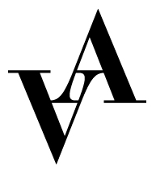

Application to production assistant 2023
Vadstena-Akademien

Production: Andefabriken (2023) Urpremiär

Place: Vadstena slott, Vadstena

Please fill out this form and send it together with CV, cover letter and 2 relevant references to apply@vadstena-akademien.org no later than February 20, 2023.

Name:

Address:

Postal number:

City:

Country:

Email:

Phone:

Birth year:

Education:

School:

Length of education:

Relevant internships within the area:

Previous experience within production:

References with contact information:

